M.SANDHIYA

YouTube Reporting API:

1.Create Credentials:

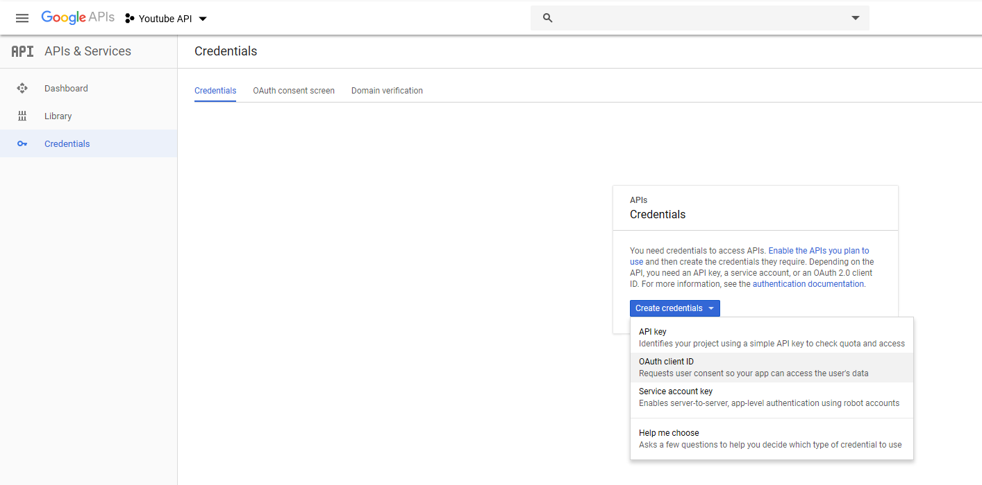

2.Authentication

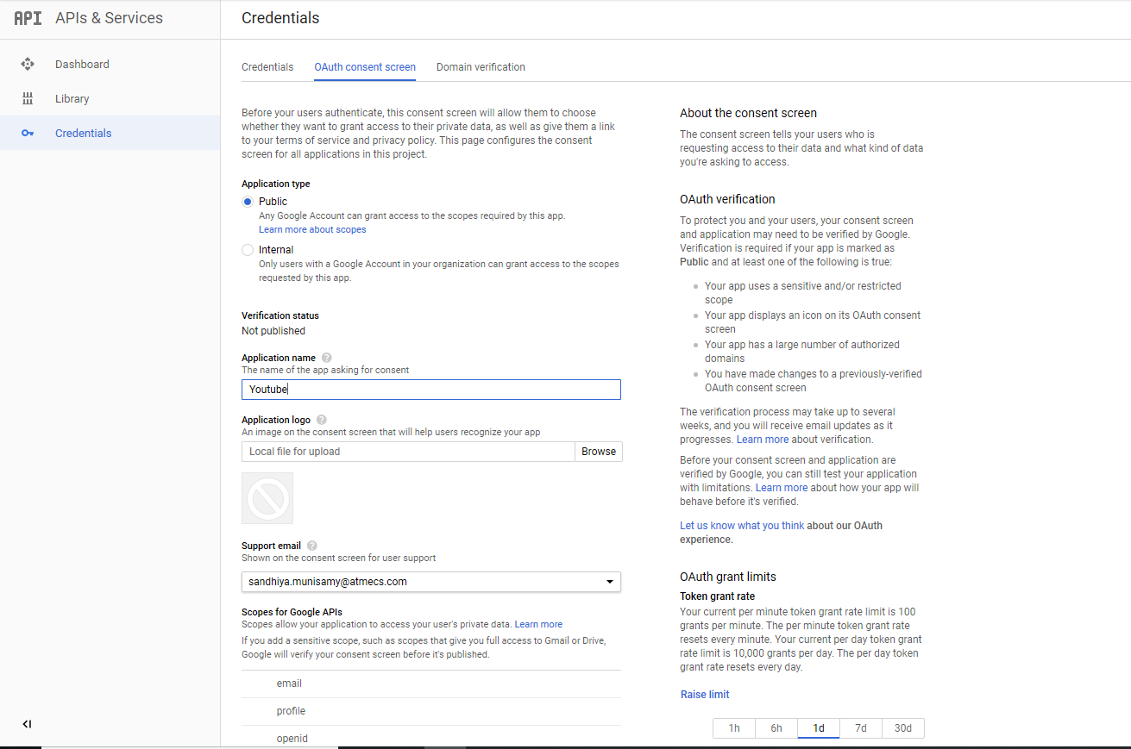

3.Creation of OAuth ClientID:

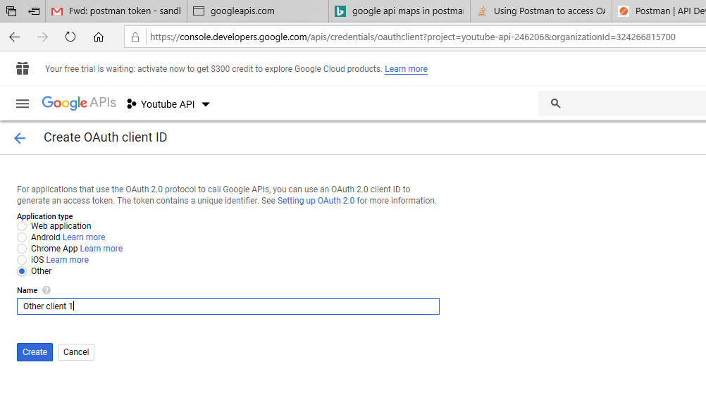

4.Generation of OAuth ClientID:

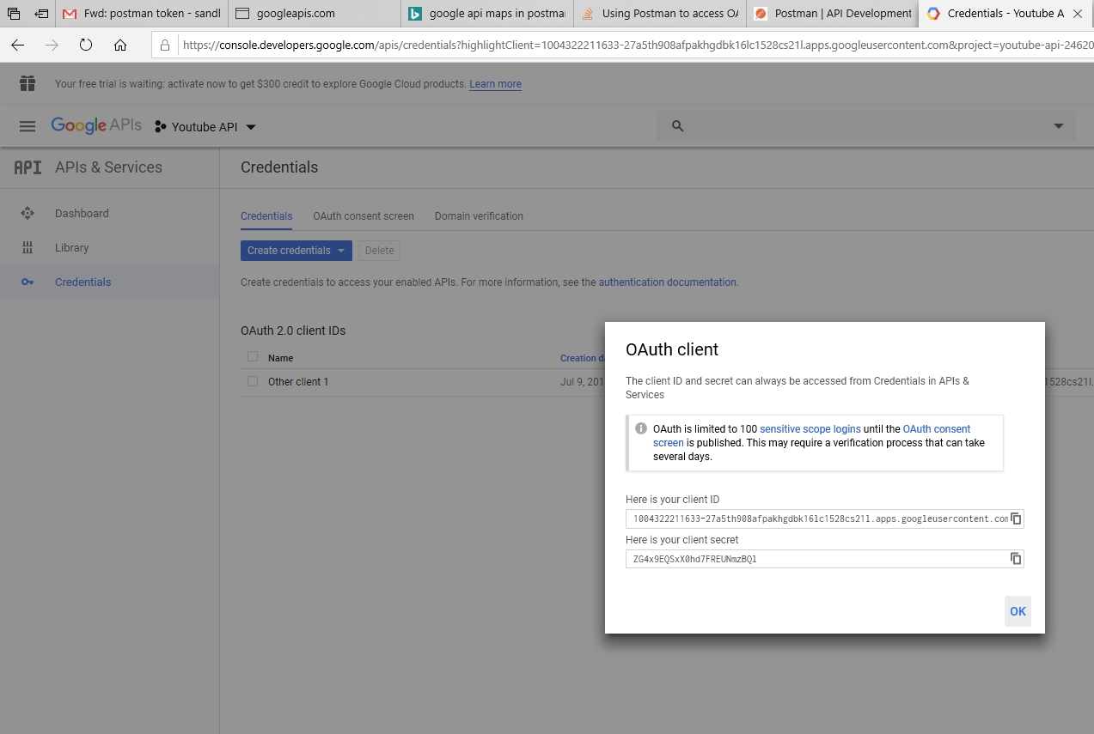

5.Get New Access Token:

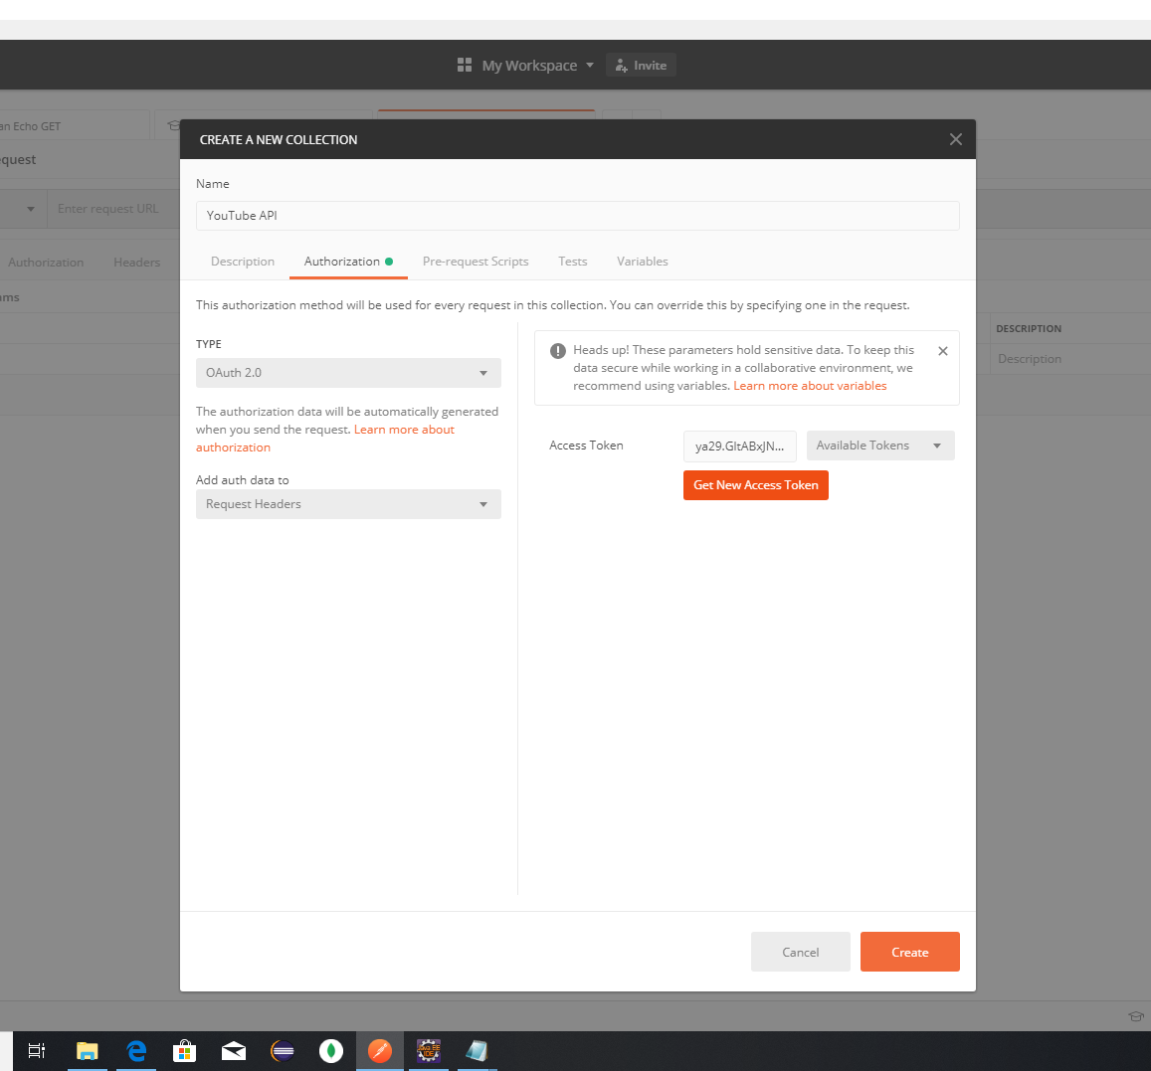

6.With the Generated JSON Client ID Request the Token:

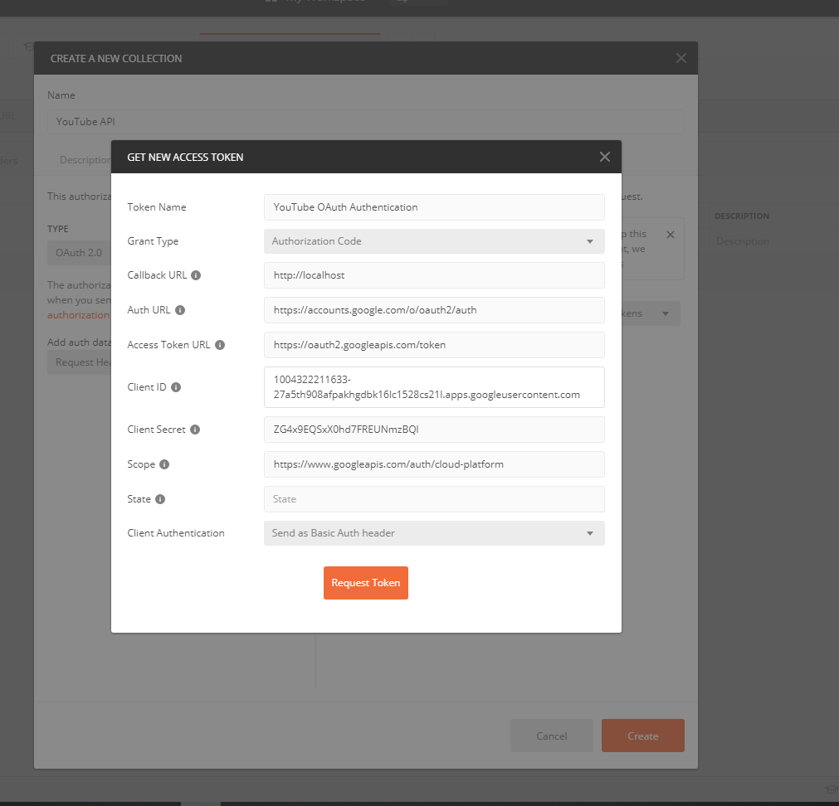

7.Signin to Google Account for Verification:

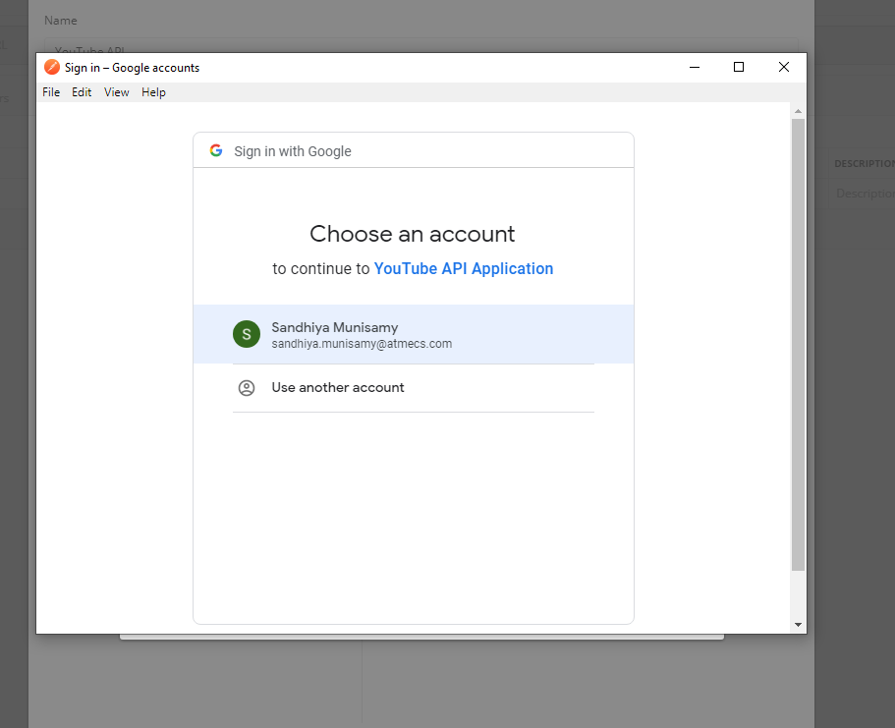

8.Success Token is generated:

